**Task 01: Power BI Virtual Internship**

**Steps to Transform the Given CSV File and Create a Sorted Power BI File**

**Step 1: Download Power BI**

* Install the Power BI Desktop application for Windows from the official Microsoft website.

**Step 2: Download the CSV File**

* Obtain the CSV file from the LLM model provided by the internship.

**Step 3: Working with Power BI**

**a) Open Power BI:**

* Launch the Power BI Desktop application on your computer.

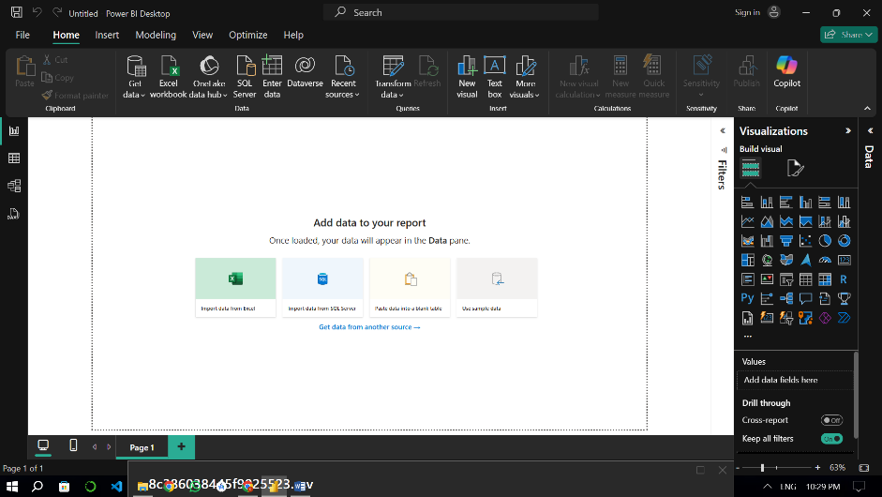

**b) Main Canvas:**

* You will see a blank white screen, referred to as the "canvas." This is the workspace for your Power BI project.

**c) Click "Get Data":**

* On the Power BI desktop screen, locate and click the "Get Data" option.
* From the list of data source options, select "CSV file."

**e) Choose the Downloaded File:**

* Browse your computer and select the CSV file downloaded in Step 2.

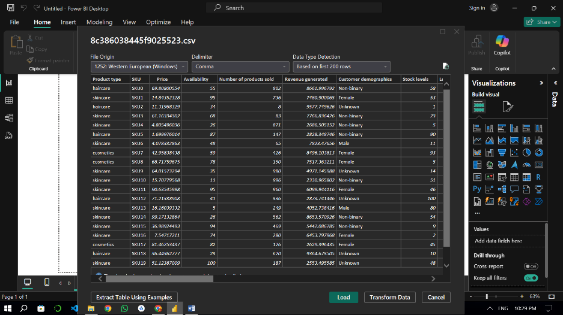

**f) Load Data:**

* After selecting the file, click the "Load Data" button to import it into Power BI.

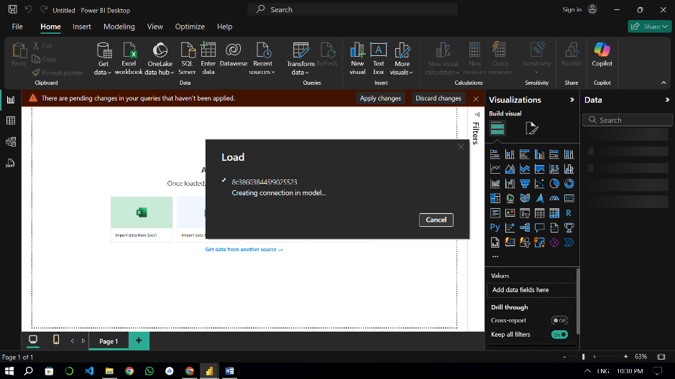

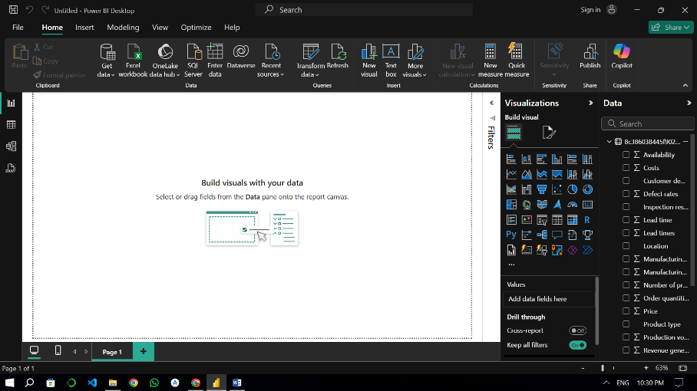

**g) Transform Data:**

* In the address bar, click on the "Transform Data" option. This will open a new window called Power BI Query Editor.

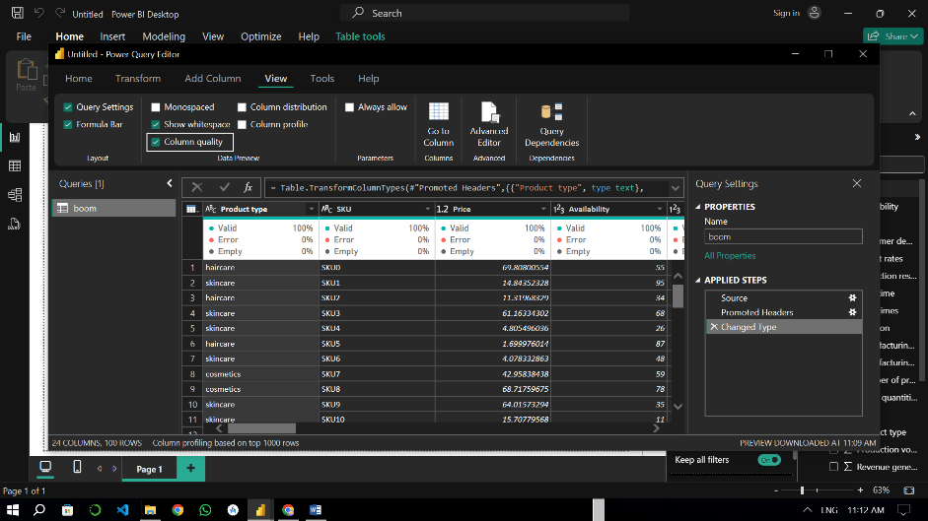

**h) Power BI Query Editor:**

* In the Query Editor window:
  1. Copy the main file (dataset) multiple times.
  2. Create separate tables for "Inventory," "Manufacturing," "Suppliers," and "Supply Chain."
  3. Use the reference provided in the documentation from the organization to sort and edit the data for each table appropriately.

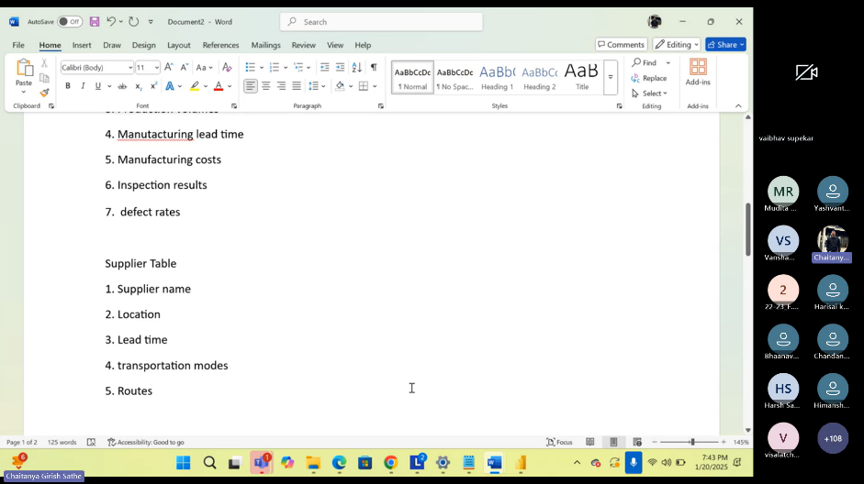

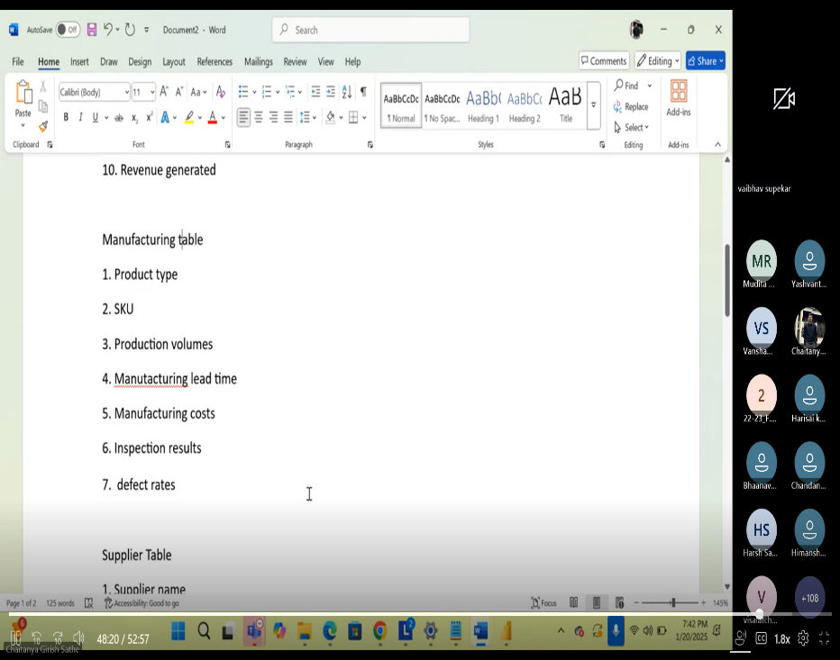

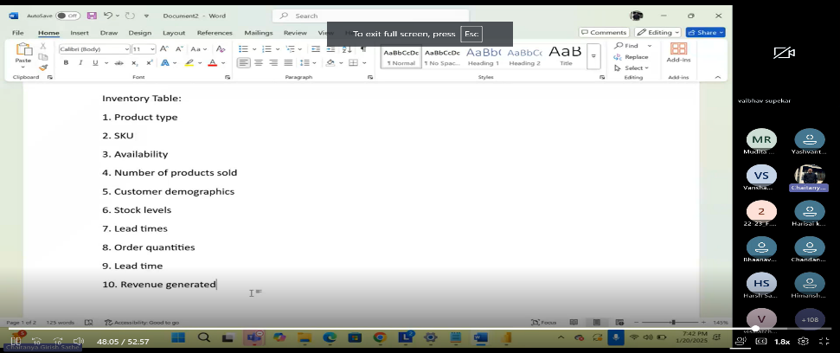

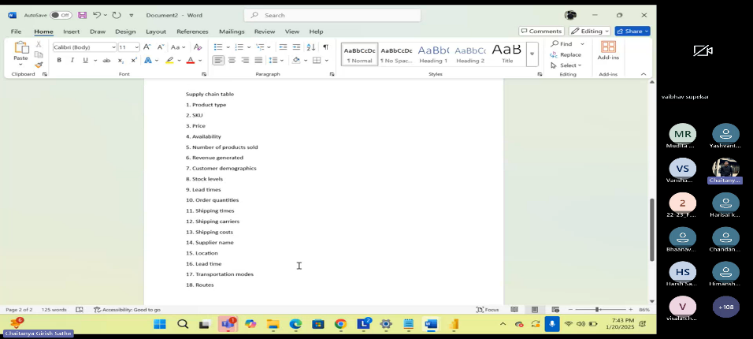

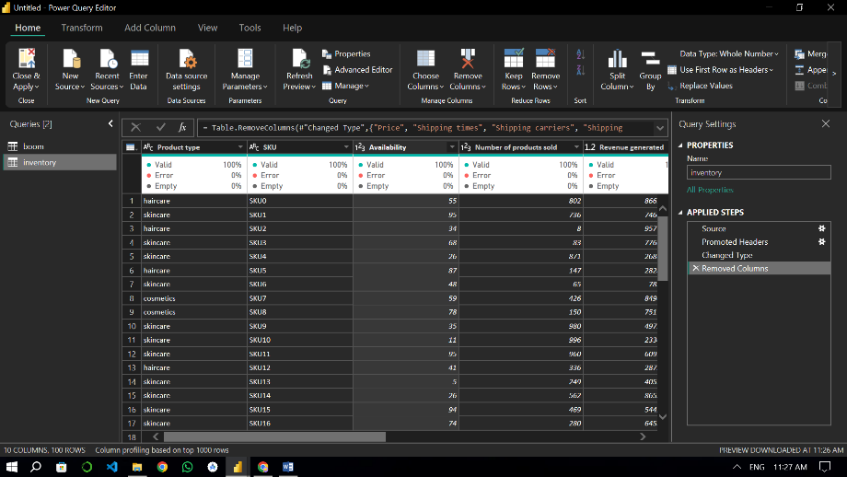

**i) Close and Apply:**

* In the top-left corner of the Query Editor, click the "Close & Apply" button to apply the changes to your Power BI project.

Final window

